Key points for students
Creating a chart in Google Sheets
This is a set of data showing the number of students in a class who travelled to school by various means.
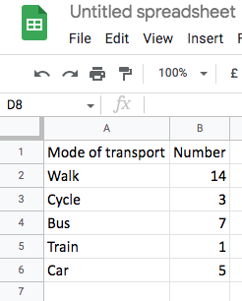
To create a bar chart highlight the data.
Select insert then chart from the menu bar.
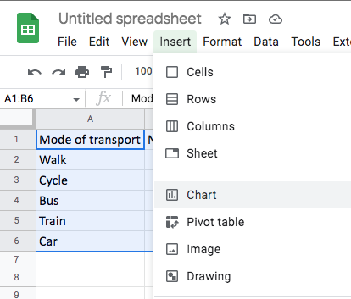
A default chart will be inserted.
To change the chart type click on the Chart editor and scroll down to bar or column chart and select the most appropriate type.
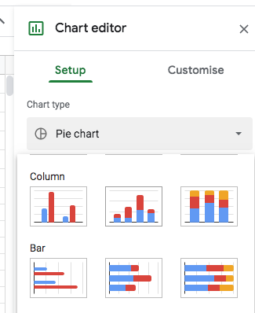
The chart will be changed to the style selected
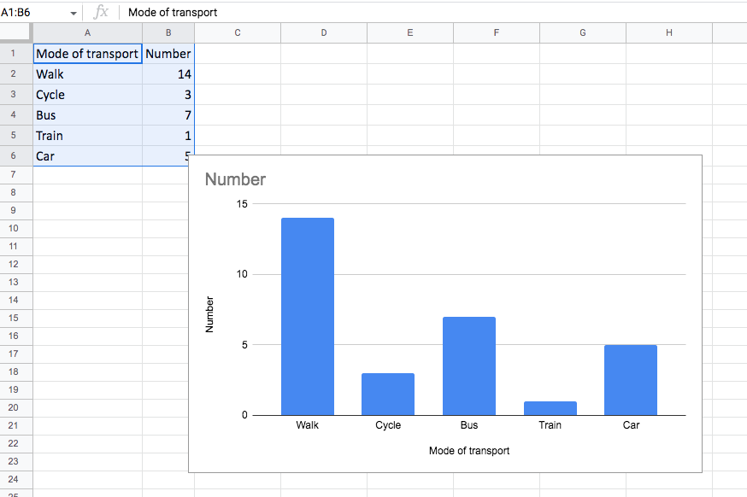
You can edit the text and format by clicking on the elements in the chart.

